Lesson – 10 Off-Page SEO
Off-Page SEO is the work done outside your own website to improve its visibility, reputation, authority, and ability to be discovered.
On-Page SEO → What we improve on our website
Technical SEO → How well search engines can crawl, understand and access our website
Off-Page SEO → What happens outside our website, especially links, mentions, citations, and reputation signals.

DoFollow Link : A normal link that can pass SEO/link signals from one website to another.
Ex: A blog writes about your electrical shop and links to your website normally.
Website A → Your Website ( Google: Can consider the link as a ranking signal. )

NoFollow Link : A link with rel="nofollow" that tells search engines not to treat it as a normal endorsement/link signal.
Ex:A website mentions your electrical shop and links to you, but marks the link as nofollow.
Website A → Your Website ( Google: Generally doesn't treat it as a normal ranking/link signal. )

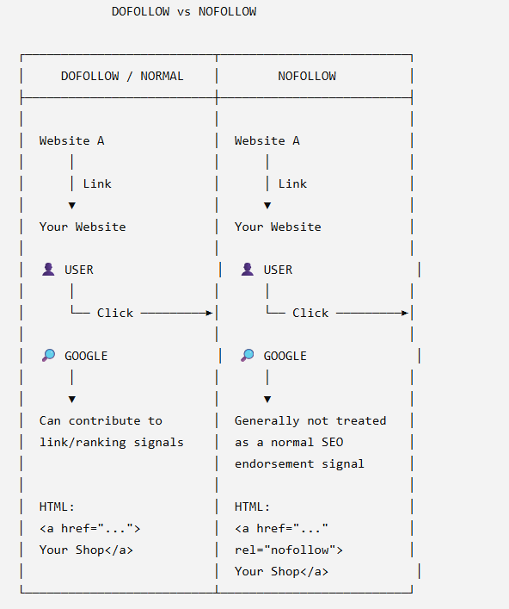

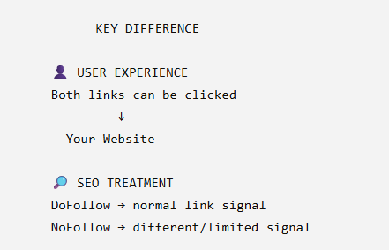

Link quality means how useful, trustworthy, and relevant a backlink is.
A good-quality link comes from a relevant and trustworthy website, while a poor-quality link comes from an irrelevant or spammy website.

Domain Authority (DA) is a score that estimates how strong a website’s backlink profile is and how likely it may be to rank in search results.
domain authority must be 25 +
Scale : 0 – 100
DA is a third-party SEO metric, mainly associated with Moz.
https://moz.com/domain-analysis

Page Authority (PA) is a score that estimates how strong a specific webpage is based mainly on its backlink profile.
• PA is a Moz metric, not a Google ranking factor.
• It is measured on a 0–100 scale.
• DA looks at the overall domain/website. PA looks at a specific page.

Moz provides SEO tools that help analyze keywords, backlinks, domain authority, page authority, and competitors.
https://moz.com/free-seo-tools
Tool | Simple
Link Explorer | Check backlinks, DA, and PA
Keyword Explorer | Find and research keywords
Rank Checker | Track keyword rankings
Site Crawl | Find technical SEO problems
MozBar | Check SEO metrics while browsing websites

Backlink checker = a tool used to find and analyze websites that link to your website.

https://moz.com/link-explorer

Social bookmarking is saving and sharing webpages on online bookmarking platforms so other people can discover them.

https://samaytraffic.samaysawara.in/signup

https://samaytraffic.samaysawara.in/story/ira-writes-personal-essays-life-reflections-love-relationships

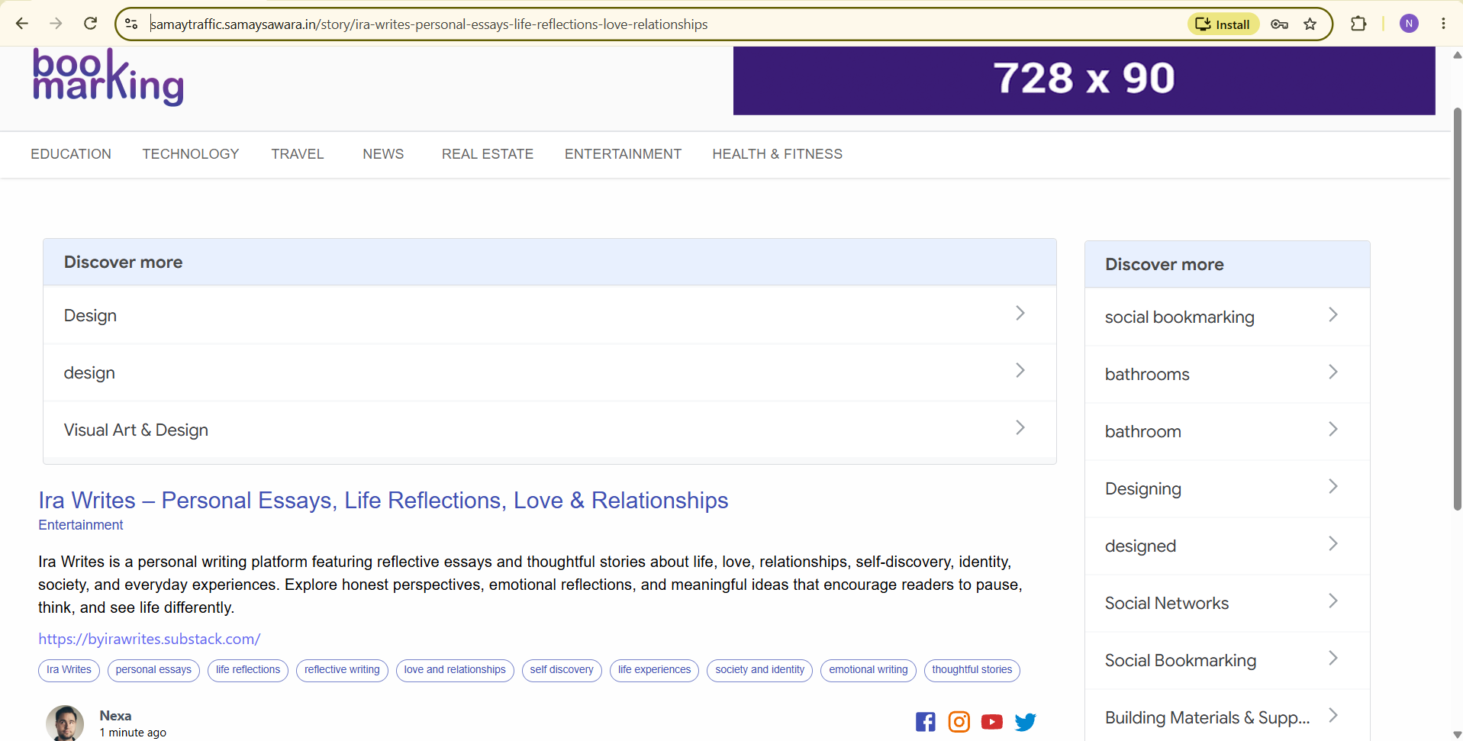

Ex : Pinterest , reddit , flipboard , diigo

Directory submission is submitting your website or business information to an online directory under a relevant category.

